**CH 245: ORGANIC CHEMISTRY 1 LABORATORY (Fall 2019)**

**Title:**

1. **Purpose: (1 point)**

The purpose of this lab is to perform a simple distillation and a vacuum distillation on a mixture of hexane and decane to separate the mixture. This process allows us to separate liquids in a mixture based on different intramolecular forces and to purify liquids in a solution.

1. **Drawing of structure of the main compound or balanced chemical equation if synthesis is performed: (1 point)**

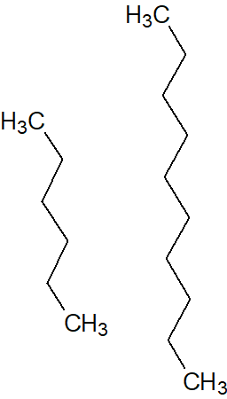

Hexane Decane

**3. Reagents and the major product (up to 6 points)**

|  |  |  |  |  |  |  |
| --- | --- | --- | --- | --- | --- | --- |
| **Name** | **M.W.**  (0.5 pts) | **Density**  (0.5 pts) | **Amount (grams/mL)**  (0.5 pts) | **Moles**  (0.5 pts) | **Hazards/Precautions**  **(MSDS data) and melting point or boiling point** (2 pts) | **Waste Disposal**  **(aqueous or organic)** (2 pts) |
| Hexane | 86.18 g/mol | 0.659 g/cm3 |  |  | Eye and skin irritation. BP: 69°C | Organic |
| Decane | 142.29 g/mol | 0.73 g/cm3 |  |  | Dryness on skin or eye irritation. BP: 172-174°C | Organic |

**4. Procedure (up to 2 points)**

|  |  |
| --- | --- |
| **Procedure** | **Observations and Lab Data** |
| A summary of the procedure done with bullet points) | Color changes, exothermic or endothermic reactions, gas generation, etc.; tare weights for flasks, etc. |
| * Place a 20-mL sample of the unknown hexane and decane mixture into a tared, clean, dry 50mL round-bottomed flask. * Record the mass of the mixture. * Set up the apparatus as shown on the demo table, with tared receiver flask. * Start distillation at atmospheric pressure. * Record the head temperature at short time intervals after the liquid starts to come over and starts condensing into receiver flask. * When the temperature begins to fall (or rise suddenly) and no more condensate is being collected, replace receiver with a second, tared 20 mL receiver flask. * Remove heat and cool. * Attach vacuum line and gradually turn vacuum to maximum. **Mixture must be at room temperature.** * Resume distillation while recording temperature of head at intervals. * Continue distilling to dryness. * Turn off heat, allow the apparatus to cool, and turn off vacuum. |  |

**5.** Results; include actual yield in grams and % yield.

**Results (need to get signed by instructor or TA):**